Chapter 10, Problem 21.

For each of the circuits in Fig. 10.70, find V_{o}/V_{i} for ω = 0, ω → ∞, and
ω² = 1/LC.

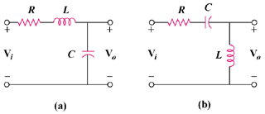

Figure 10.70
For Prob. 10.21.

